1. A dropdown menu that features a list of countries and their phone codes. The option text should have the name of the country as well as the code like “Afghanistan (+93)” but when clicked on the option, the value should be set as “+93”

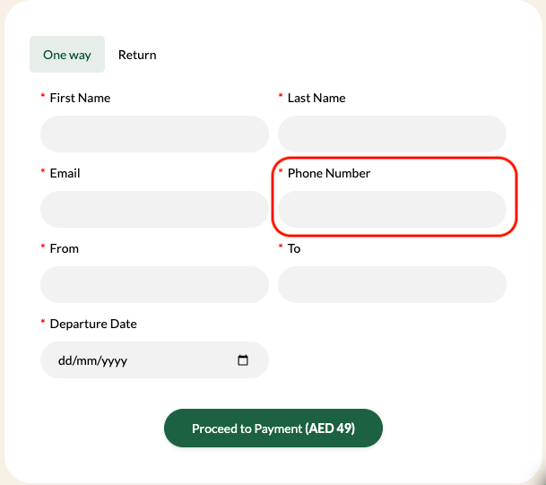

2. The form fields From and To should have a search function which allows people to search for airports in the world.

